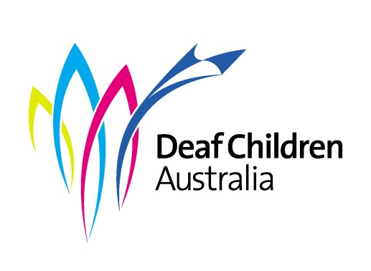
YOUTH GRANTS 2020

Background of the Youth Grants

The Youth Grants program was established in 2000 and is now Australia-wide. The purpose of the grants is to assist, inspire and encourage Deaf and Hard of Hearing youth in Australia.

Who is Eligible?
- Deaf or Hard of Hearing young people between the ages of 15-23 are eligible for a Youth Grant.
- You must not be 24 years old by the end of your project.
- Only Australian residents and Citizens can apply for a Youth Grant.

How does it work?
- DCA provide Youth Grants every year.
- The most money you can get is $2,500
- You have to start your project this year (2020) and you have 12 months to finish. For example, from July 2019 – June 2020. Please contact us if you cannot start this year.
- You can apply for a grant for your own project or for a group project. Each person in the group must complete a separate application form saying how they will benefit from the project.
- You must keep receipts and invoices of your expenses. At the end of your project, send them to Deaf Children Australia with the claim form and we will then pay you for that amount. Claims must be made by March 31st, 2021).
- New applicants receive priority and if you have applied before for a similar project, you will not be funded.
- You must submit a report to Deaf Children Australia within thirty days of finishing the project (see Project Report guidelines below). The report must include photos and/or video. The report may be in the form of an Auslan video.
- By applying for a Youth Grant, you are agreeing to Deaf Children Australia writing a story about your project on our website and including it in our newsletters and social media.
- If there is any publication, news outlet, social media or other publicity covering your project, you are asked to talk or write about the support given to you by Deaf Children Australia.

Project Guidelines

Personal and Community Benefits

Your grant application needs to state how this project will help you reach your potential and inspire other young deaf and hard of hearing people. You may also show a benefit to the deaf and hard of hearing community, or wider communities throughout Australia.
The benefits will be different, depending on each project and grant category. Your project may help a community directly. For example, running a social club for young deaf or hard of hearing children or establishing a horse-riding school for other young people with disabilities. Or the benefit may come from sharing your experiences with others and inspiring them to reach their own potential.
Deaf Children Australia would like the grant recipients to inspire other deaf or hard of hearing children and young people to achieve their full potential and be positive deaf role models.

What types of things can you apply for?

- Personal Goals

A dream, ambition or personal goal that may boost your self-esteem and contribute to your personal development, for example, showing your creative talents through an art exhibition or a play, or following your dream to travel overseas.

- Deaf Community & Culture

Exploring an aspect of Deaf Community and Cultures such as:

  - exploring other people’s life experiences and values;
  - visiting a deaf facility in another state or overseas;
  - volunteering to work at a deaf facility;
  - attending an exchange program overseas;
  - studying the history of the Deaf community; or
  - visiting deaf and hard of hearing children in isolated/rural areas.

- Leadership Skills

Funding to develop your leadership skills and provide a positive image of young deaf people to the wider community. You might set up a deaf youth club or establish a sporting club for young deaf or hard of hearing people or young people with disabilities.

- Education

Opportunities to expand your educational experiences at Secondary, TAFE or university. This could be attending a special conference or event related to your course to help develop career opportunities.

- Life Experience

For example, participating in a team sport and representing your state or Australia against other teams and competitors.
Reporting on your project

After your project is finished, you must write a project report telling us about your project. Some questions to think about are:
- What did completing this project mean to you?
- What did you learn from the project?
- What did this project allow you to achieve?
- Why did you decide to apply for this project? Is it an activity offered at your school or sports club, or just your own idea?
- What went well with the project?
- What obstacles did you face with the project? How did you overcome them?
- What would you do better next time?
- Would the project have been as successful without DCA awarding you this grant?
You can send us an Auslan or spoken English video, or we can interview you (ask questions) about your project. You will need to include photos or a video of your project.

Applications that will not be considered

The following types of projects WILL NOT receive grants from Deaf Children Australia’s Youth Grants:
- Applications by or on behalf of an organised group such as schools, voluntary groups or youth clubs. If you are part of a group or youth club and want to apply for a personal Youth Grant for your project, you are welcome to do so, but your group cannot submit an application for everyone.
- Applications for assistance that should be covered by health, education or employment services, or the NDIS.
- Leisure camps and school trips will not be funded unless you are travelling to experience other cultures, or a direct personal or community benefit can be shown e.g. Leadership camps, Duke of Edinburgh medals, Aboriginal community experiences, overseas travel.
- Computers (including laptops), hardware and software will not be provided unless the applicant has an additional disability and can show its need for their education

How to complete your application

All questions must be answered. We do not accept applications that haven’t been completed.

It is important to keep the following things in mind when completing the application form:

- Have a good understanding of the project – do the research.
- Understand how you will benefit personally, and how the community will benefit from your project.

There are three ways to give us your application:
First, download the application form from our website or contact us to request a copy (contact details at the bottom of page). You can fill the form in directly and email it through to us. Alternatively;
- Print the application form and complete it by hand. Make sure your handwriting is clear. Then email or post to Deaf Children Australia (details at the bottom of page) or,
- Make a video. Please be brief and answer the questions from the application form in Auslan or spoken English. You should upload your video on YouTube and provide the link in Question 1 of the application (Title of the Project). Alternatively, you could send your video to DCA via WeTransfer (www.wetransfer,com ).
- You must complete referees and authorisation on the application form, then email or post it to Deaf Children Australia (see details below).

If you have any questions, contact:

Youth Grants
Deaf Children Australia
Tel 03 9539 5300
Email youth.grants@deafchildren.org.au

Post completed application forms to:
Youth Grants Coordinator
Deaf Children Australia
PO Box 6466
Melbourne 8008

Or email the application to youth.grants@deafchildren.org.au

Applications close 5 pm, Tuesday the 30th of June, 2020
Good Luck!

