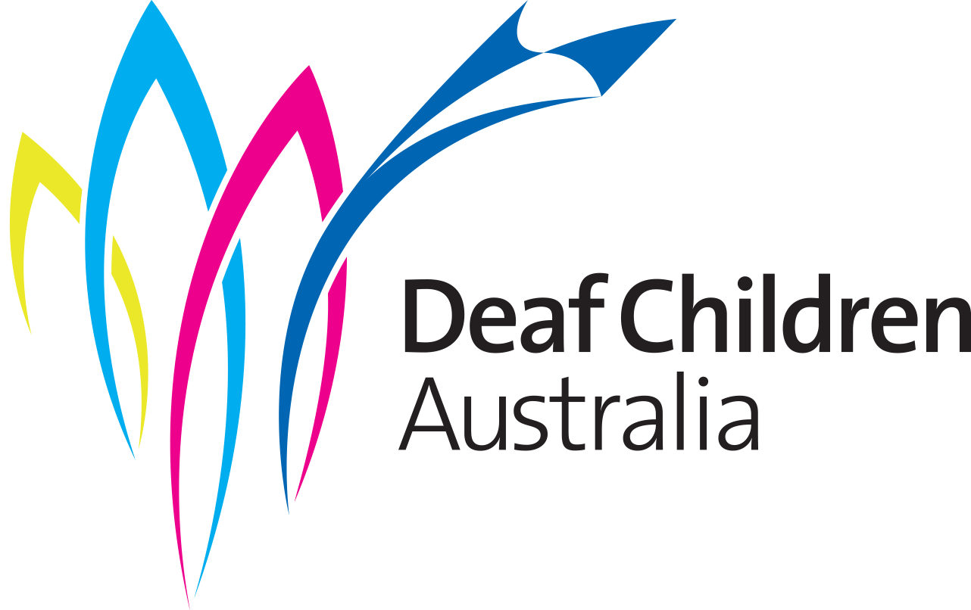

YOUTH GRANT CLAIMS FORM

You will need to claim the money back for your project by 31 March 2022 – except if you apply for an extension because of special circumstances.
When sending your receipt/invoice to Deaf Children Australia, please fill out and attach this form.
NAME
AMOUNT GRANTED |  | $
- How much are you claiming? |  | $
Please ensure that the cost does not exceed the amount Deaf Children Australia approved for you.
- How do you want the payment to be made?
By Electronic Funds Transfer (EFT) – please complete question 3
By cheque – please complete question 4
- If claiming by EFT:
- Bank:
- BSB:
- Account number:
- Name on account:
- If claiming by cheque:
Who do you want the cheque to be made out to?
- Name of payee:
To who and where do you want the cheque sent?
- Name
- Street Address
- Suburb |  |  |  | - Postcode

Please note that EFT payments are made on Thursdays. Please make sure you have attached a receipt/invoice to this form and forward it to:
Youth Grants
Deaf Children Australia
PO Box 6466 Melbourne 8008
E: youth.grants@deafchildren.org.au
P: 03 9539 5300

OFFICE USE ONLY:

Date Received:

Date Paid by Accounts:

Date report required by:

