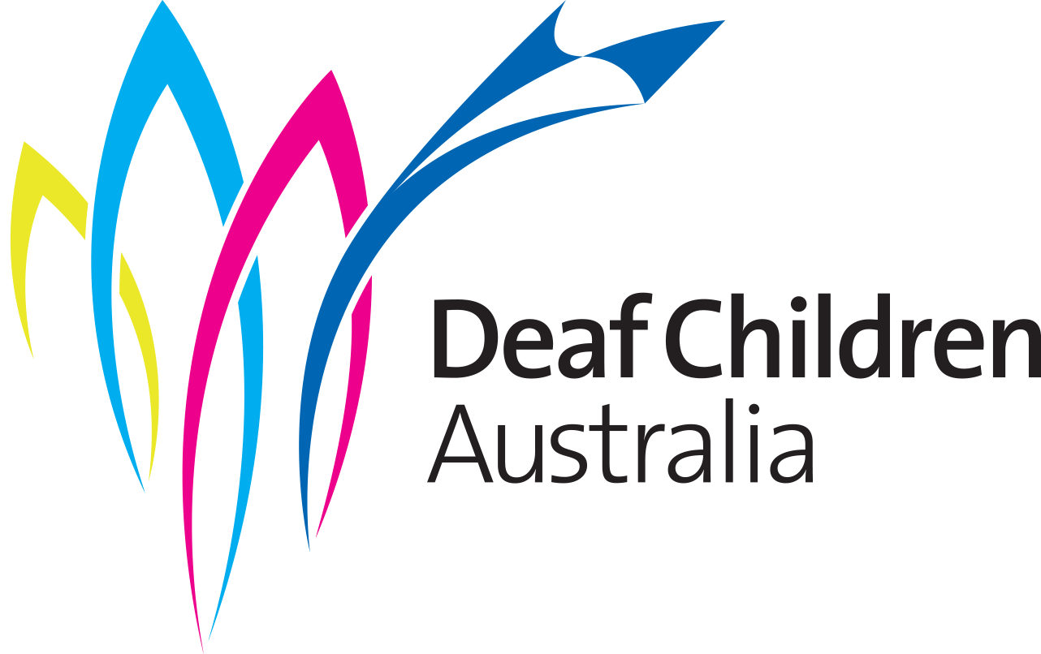

YOUTH GRANT APPLICATION FORM 2021
Deaf Children Australia’s Youth Grants were established to help deaf and hard of hearing young people to achieve their goals in personal development, Deaf culture and community, life experience, leadership challenges and education.

Youth Grants are available to all residents of Australia who are deaf or hard of hearing and aged between 15 to 23 years.

Deaf Children Australia’s Youth Grants were established in 2000 with support from our philanthropic partners. Deaf Children Australia adds to this Victorian funding to make the Youth Grants available Australia-wide.

Before applying, please read the application conditions.

If you have any questions:

Youth Grants
Deaf Children Australia
Tel 03 9539 5300
Email youth.grants@deafchildren.org.au

Closing Date is 11:59 PM, 6 June 2021

Please print neatly in blue or black pen or type your responses and submit your application via email, fax or post to:

Youth Grants
Deaf Children Australia
PO Box 6466
Melbourne 8008
Email youth.grants@deafchildren.org.au

Tell us about yourself
Name
Gender |  |  |  | Date of birth
Street Address
Suburb |  |  |  |  | Postcode
Phone
Email
Preferred communication method
Auslan
Signed English
Oral – spoken English
Other (please specify)
Are you currently studying? |  |  | Yes |  | No
If yes, please give details (name and place you are studying at, year level/course, etc.)
Parent/Guardian’s Contact details (please complete if under 18)
Name
Street Address
Suburb |  |  |  |  | Postcode
Phone
Email

Tell us about the project
You can provide your answers to this section in Auslan if you prefer. Provide a link to your video in Question 1 or send your video via WeTransfer. All other sections of the application must be written.
Important: You can provide your answers to this section in Auslan if you prefer.
- Title of the project
- Tell us briefly what your project is about? (e.g. to join a World Challenge trek, represent your state or country in your sport, or get specialist equipment to help with your studies)
- Give us five reasons why DCA should give you a youth grant.
- Tell us how long your project will be. (Your project plan must be completed within 12 months. Explain how long your project will be e.g. a four-day workshop or two weeks travel)
- Where will your project be based? (e.g. this could be somewhere in your home state, another state or another country. Please give us full details.)
- Who will you be working with? (e.g. this could be an overseas volunteering organisation or a group of parents of deaf children)
- Why have you chosen this project? (e.g. explain why this is helping you achieve goals)
- What steps will you take to reach your goal? (e.g. do you have a project plan?)
- Tell us how you will benefit from your project (e.g. you may learn new skills on leading a small team or develop your skills in sport)

- Tell us how much your project is going to cost and how much money you are applying for. If your project will cost more than the money you are granted, how do you plan to get the rest of the money? Try to break down the costs for each part of your project plan. You can provide us with the information on another page. You must send us a copy of the quote or any lists of costs. Your costs may be more than our maximum grant of $2,500.
Total project cost: | $ | Amount applying for: | $
- Will you have a support person to help with your project? (e.g. a family friend, parent or teacher). If yes, please give us the name and address of this person and tell us what they do. Explain how they will support you in this project.

- Who completed this application?
Name
Referees
Professional Referee (e.g. teacher, TAFE or university tutor or employer)
Name
Street Address
Suburb |  |  |  |  |  | Postcode
Phone
Email
Personal Referee (someone who knows you well)
Name
Street Address
Suburb |  |  |  |  |  | Postcode
Phone
Email
Authorisation
The information supplied in this application is correct to the best of my knowledge.
I understand the criteria under which the grants are made. I also understand and agree that Deaf Children Australia may use my story for publication purposes. This includes photos, videos, images and quotes from your project.
Applicant - please sign your name and date. If you are under 18 years of age, you must get your parent or guardian to sign:
Your name (print)
Signature |  |  | Date
I am the parent/guardian of |  |  |  |  | and I fully support this application
Name of signatory
Signature |  |  | Date

